NATIONAL RESTAURANTEXCHANGE

*(617)721-9655 Fax : (781)246-5000*

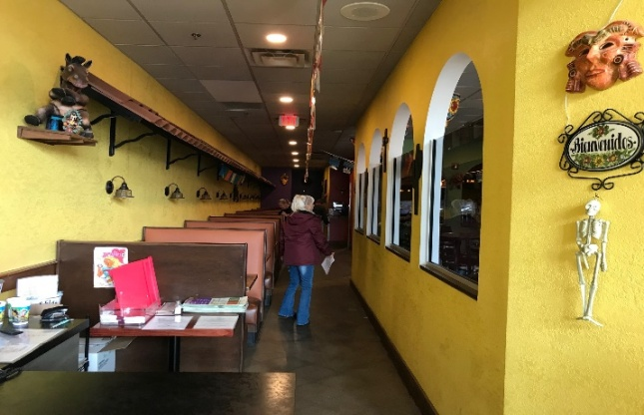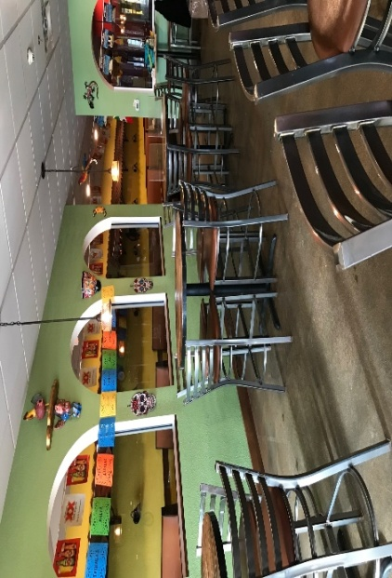[dserpone@comcast.com](mailto:dserpone@comcast.com)

**TYPE OF BUSINESS:** Mexican Family Style Restaurant

**LOCATION:** Salisbury/Amesbury

**SELLING PRICE:** $125,000

**DOWN PAYMENT:** $50,000

**SALES VOLUME:** $28K/wk. %**Delivery:** no

**LEASE:** New Lease **YRS. LEFT:**

**SQUARE FOOTAGE**: 3,000 sf.

**HOURS OF OPERATION:** 11am – 10 pm, 7 Days

**SEATING:** (inside) 96 (outside) 20

**REASON FOR SELLING:** Running two operations, time to slow down

**COMMENTS:** Locatedin a very well-kept strip mall with a major supermarket as its anchor. On a very heavily travelled numbered route that intersects with a major interstate.The concept is Mexican with no competition around for miles, but with very little effort it can be almost anything. Great bar that seats 15 with plenty of TV’s visible from all over. Needs to have delivery added and promote home party platters and the sky is the limit.

Absentee owners draw $100K per year.