NATIONAL RESTAURANT EXCHANGE
(617)721-9655 Fax: (781)246-5000
DSerpone@comcast.net

LISTING INFORMATION

SALEM~NASHUA area~~UPSCALE ‘TAPAS’ RESTAURANT& BAR, FUNCTIONS
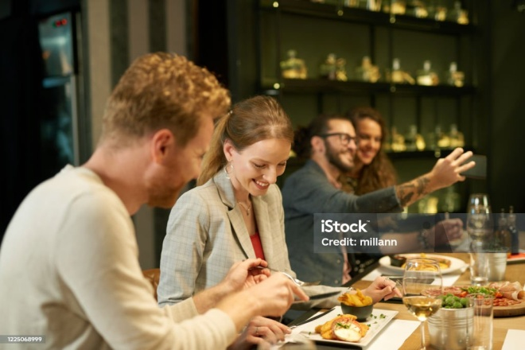

SELLING PRICE: $700K DOWN PAYMENT: ONLY $150K dn
SALES VOLUME: $15K - $20K/wk

LEASE: $10K/mo. gross Years left: 1 YR + 3 five yr. options
SQUARE FOOTAGE: 5,100 sf.

HOURS OF OPERATION: 5 days; mostly 4 pm – 10 pm, Sun: 3 pm – 8 pm

SEATING: 136 inside & outside (24 seats at inside bar, 12 seats at the outside bar)

REASON FOR SELLING: Significant family health issues.

COMMENTS: Food cost: 25%, labor: 17%-22%...30 craft beer taps, 10,000 followers on Facebook and $250,000 in catering contracts make this an excellent opportunity for a seasoned operator. Live entertainment most nights. Huge parking lot on a major road; town sewerage. Over 1,000 new hi-end apts. close by. Over a million was spent on the build-out…mostly in the kitchen.

THE BUSINESS NEEDS A CONCEPT ADJUSTMENT.
Wait till you see this place. This is the DEAL OF THE CENTURY for an experienced operator.
Call Dennis at 617-721-9655 or dserpone@comcast.net

