NATIONAL RESTAURANTEXCHANGE

*(617)721-9655 Fax: (781)246-5000*

DSerpone@comcast.net

# LISTING INFORMATION

**NEW~~TWO FAST FOOD OPERATIONS w/franchise capability**

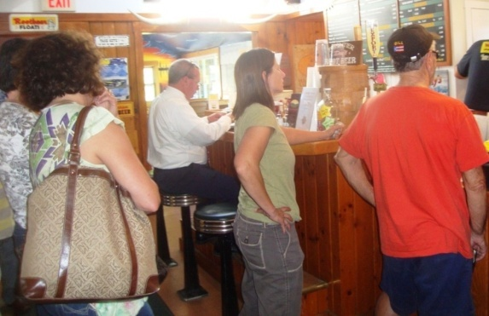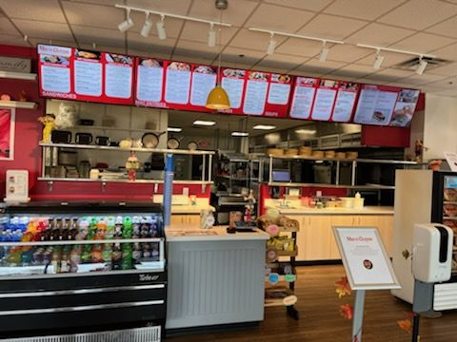

**LOCATION:Tyngsboro & Westford**

**SELLING PRICE:**$495K for both locations**DOWN PAYMENT:**$100K each

**SALES VOLUME: Each location averages $10K - $14K/wk**

**LEASE:Tyngsboro:** $9,400/mo. gross**Years left:**3 yrs. + (2) 5 yr. options

**Westford:** $8,200/mo. gross **Years left:** 6 yrs. + (2) 5 yr. options

**SQUARE FOOTAGE:**Tyngsboro: 4,000sf. Westford: 3,000 sf

**HOURS OF OPERATION:**7 days: 11am **-** 8 pm

**SEATING: Tyngsboro** 84 inside

**Westford** 49 inside 12 outside

**COMMENTS:** Build out a couple of years ago was close to $2 million. Absentee owner is shifting his interests to real estate providing a seasoned operator with a unique opportunity…franchise the concept (docs are prepared) or sell off one unit. SBA financing is readily available. Both locations are located in large shopping centers. Staff is very experienced and will stay with new owner. NO COMPETITION yet this concept has huge general appeal.

**Contact John Ruggieri at 781-858-2343 or jkruggie@comcast.net.**