NATIONAL RESTAURANTEXCHANGE
(617)721-9655
dserpone@comcast.com

LISTING INFORMATION

Owner's Cell: ___________________________ Owner's email: _____________________________

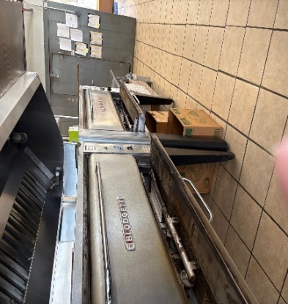
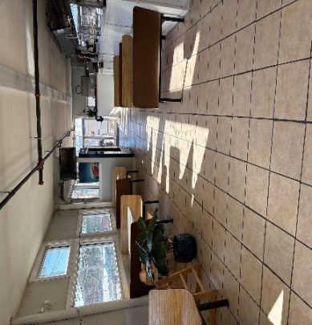

TYPE OF BUSINESS: Greek style Pizza & Subs

LOCATION: Chelmsford/Lowell

SELLING PRICE: $295,000

DOWN PAYMENT: $100,000

SALES VOLUME: $11,000 wk. 30%Delivery:

LEASE: $3,000/mo. (NNN Inc.) YRS. LEFT: New Lease

SQUARE FOOTAGE :2,000 sf.

HOURS OF OPERATIONS: M, W 11-9 pm TH, F, S 11-11 pm Closed Tues.

SEATING: (inside) 30

REASON FOR SELLING: Retiring

COMMENTS: A very well-kept and efficiently set up Pizzeria on a very visible corner location. Just blocks away from a bustling downtown center. On a major numbered route and minutes from a major interstate and the U Mass Lowell Campus.
Has off street parking and does delivery.

Contact: John Ruggieri at 781-858-2343 or jkruggie@comcast.net

