NATIONAL RESTAURANT EXCHANGE

*(617)721-9655 Fax: (781)246-5000*

DSerpone@comcast.net

# LISTING INFORMATION

**HARWICH-BREWSTER area~~ FAMOUS Restaurant & Pizza Pub w/large real estate**

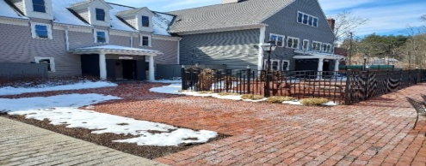

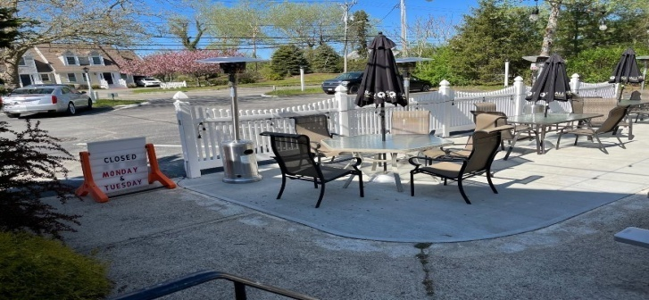 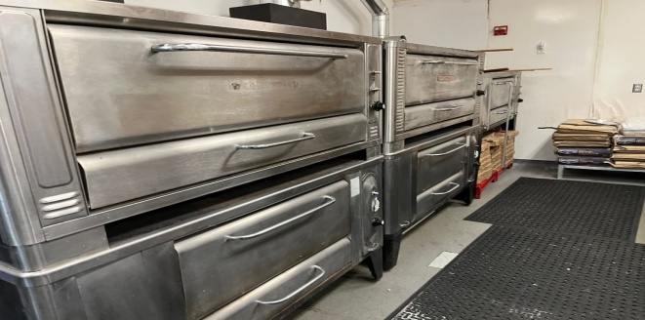

**SELLING PRICE:** $395K for the business with only $150K cash down payment required and a two-year option to buy this large parcel of real estate at Fair Market Value as determined by an independent appraisal. This is one of the biggest parking lots in the area with TOWN SEWERAGE.

**SALES VOLUME:** Averaging $18K-$20K/wk.Strong online ordering & pick up

*(2022 tax return & 6-month 2023 P&L due shortly)*

**SQUARE FOOTAGE:** Bldg. is 3,064 sf. lot is approximately ¾ acre

**HOURS OF OPERATION:** 6 days; 11 AM – varying closing hrs.

**SEATING**: 97 inside 54 outside

**COMMENTS:**  VERY rare opportunity to buy into such a affluent business community…businesses, especially with real estate, just don’t become available. Full liquor licenses are in high demand. Town sewerage is a distinct advantage. Entertainment is under utilized. This family operation is ready to grow with professional management. Health issue force sale. **This is the first time that this property has been available for 25 years.**

**Call Dennis at 617-721-9655 or email at dserpone@comcast.net.**