**DRACUT-METHUEN area~~local SPORTS BAR w/ OPTION ON REAL ESTATE**

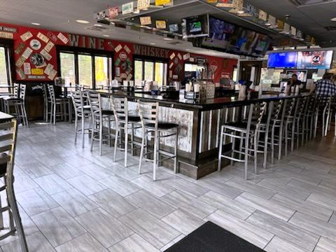 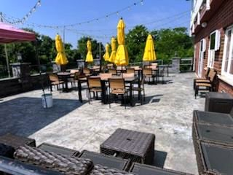

**SELLING PRICE:** $325K for the business **DOWN PAYMENT:** $125K

$1,475,000 for the entire Sports Bar/ RE package. This is an fantastic opportunity.

**SALES VOLUME:** $18K-$20K/wk

**LEASE:** $5K/mo. +NNN NEW 10 yr lease available

**SQUARE FOOTAGE:** approximately 2,500sf. plus huge dry basement.

**HOURS OF OPERATION:** Closed Mondays, 6 days, 3 PM– 2 AM

**SEATING**: 134 inside 40 outside patio

**COMMENTS:**  This is another classic local watering hole…80% daily regulars. 25-seat rectangular bar, pool table and live music on the weekends. Big, beautiful New patio for summer nights. Located in a large shopping center on a very busy road. 5 business offices included upstairs for rental income.

Adjacent closed restaurant space is available for an expansion of the kitchen or dining area/ (same owner.) Keep the existing bar business or modify for more dining. Rare 2 AM liquor license. Recently appraised $1.5 mil.

2 year option on the Real Estate at Fair Market Value…..in 2026 if you buy just the business for $325,000. Must have experience to obtain the owner financing.

Must fill out NDA to receive any info on the business location, sales figures or real estate. Call 978-715-5405 to meet the owner and do a walk through.

Call 978-715-5405 to meet the owner.