NATIONAL RESTAURANT EXCHANGE

*(617)721-9655*

DSerpone@comcast.net

# LISTING INFORMATION

**MARLBORO area…on major lake ~~BREAKFAST-Lunch-Dinner**

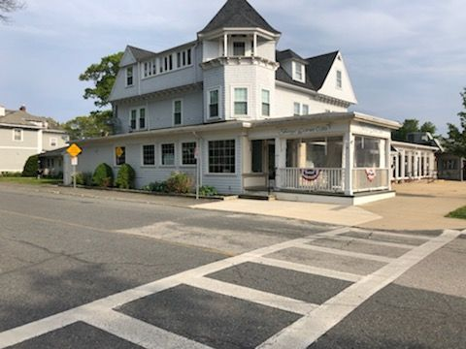 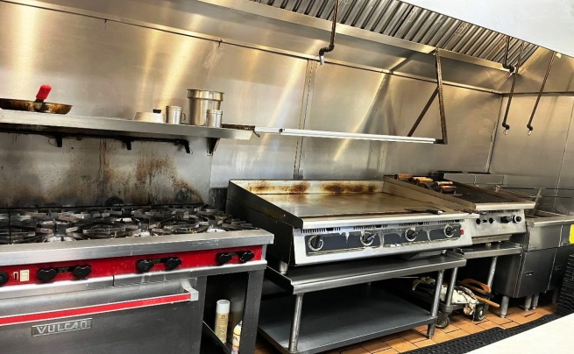

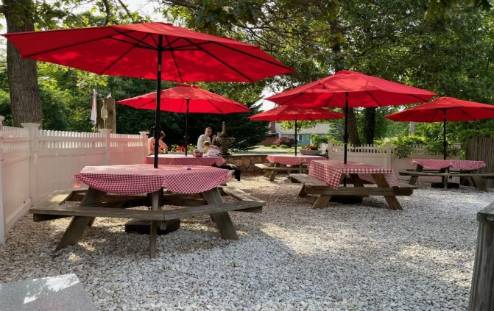 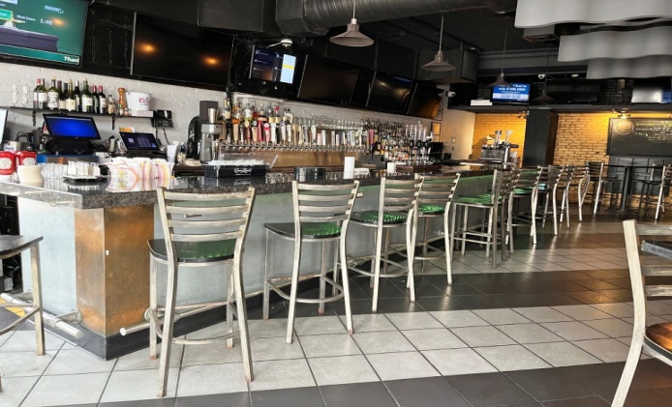

(stock photos)

**SELLING PRICE:** $395K …no seller financing

**SALES VOLUME:** Averaging around $1.2M/yr or **around $25K/wk.**

**SQUARE FOOTAGE:** 3,800sf.

**HOURS OF OPERATION:** 7 days, 7 am – 9 pm (Sundays till 3 pm)

**SEATING:** 96 inside 38 on leftside patio, 76 on rightside patio overlooking lake

**REASON FOR SELLING:** redeveloping a huge project

**COMMENTS:**  Owner in the process of building an approved outside bar on left patio.

Seller spending over a million dollars to expand the property and open access to the lake.

This restaurant is renown for its breakfasts for over 40 years. Full liquor license and bar.

The name doesn’t go with the sale but can be used for a while.

**FIRST TIME OFFERED!**

**Call Dennis at 617-721-9655 or dserpone@comcast.net**