**TEWKSBURY-WILMINGTON~~super popular PIZZA PUB**

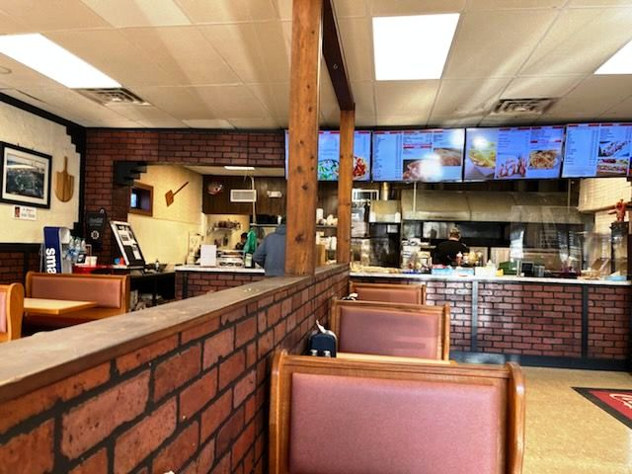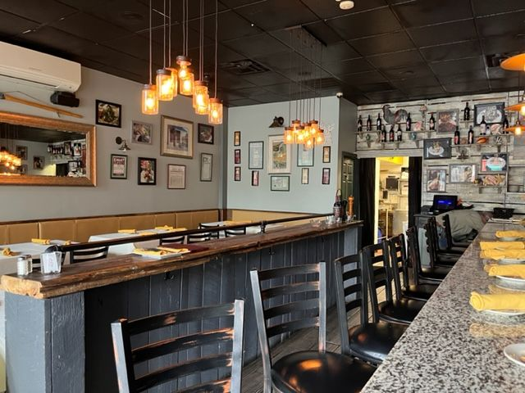

**SELLING PRICE:** $800,000 **DOWN PAYMENT:** $200K

SBA financing readily available…sellers motivated…make an offer.

**SALES VOLUME:** $1.1M **($25K/wk.)**

**LEASE**: $6,300/mo. gross

**SQUARE FOOTAGE:** 4,000sf. (separate bar area for private parties up to 99 people)

**HOURS OF OPERATION:** 6 days; closed Monday, most days 11 am – 11 pm

**SEATING:** 52 pizza 64 pub (99 max)

**Estimated Annual Net Profit: $250K/yr**

**REASON FOR SELLING:** retiring after 30 yrs.

**COMMENTS:** In operation for the last 32 years on a very busy numbered route in the Tewksbury/Wilmington area. The pub was recently added and has a great sports bar look with lots of TV’s and seating up to 99 patrons. Each partner gets $150K salary and feels it is time to retire. Real Estate may become available through an option of first refusal. What’s missing is Keno! Add keno and you will increase sales and profit unbelievably.

This is the most successful pizza pub in the region.

Contact: John Ruggieri at 781-858-2343 or jkruggie@comcast.net